EVENT TOPIC: One-Day Entrepreneurship Awareness Program
DATE: 24th Feburary 2025
PARTICIPATING STUDENTS: Students of B.Pharm

Objective of Event: To provide valuable insights to aspiring entrepreneurs and students, enhancing their knowledge of entrepreneurship and the support structures available through various government and financial institutions.
Description of event: Arihant School of Pharmacy and BRI in collaboration with the MSME-Development & Facilitation Office (MSME-DFO), Ministry of MSME, Government of India, organized a One-Day Entrepreneurship Awareness Program. The event was designed to provide valuable insights to aspiring entrepreneurs and students, enhancing their knowledge of entrepreneurship and the support structures available through various government and financial institutions. Various lectures of keynote speakers like, Shri Hiranya Vyas, Ex. CED Trainer, Gandhinagar, Gujarat; Shri Rajesh Kumar, Assistant Director, MSME-DFO, Ahmedabad; Shri Diljit Singh, Branch Manager, Bank of Maharashtra & Shri Vipul Patel, Lakshya Education and Foundation, Ahmedabad.
Outcome of event: The event was a successful initiative in promoting entrepreneurship and fostering the growth of small and medium enterprises, aligning with the Government of India's vision of empowering the next generation of entrepreneurs.

NAME OF EVENT: Campus Chronicles – 2025
DATES: 3rd February 2025 to 6th February 2025
TOTAL PARTICIPANTS: Approximately 250+ students and staff
Objective of the Event:
To promote creativity, cultural expression, professional grooming, and team spirit among students by celebrating theme-based days as part of extracurricular engagement.
Outcome of the Event:
The event fostered student collaboration, creativity, and cultural appreciation, while also enhancing professional presentation and leadership skills, boosting campus liveliness, and offering a well-rounded platform for extracurricular growth and enjoyment.

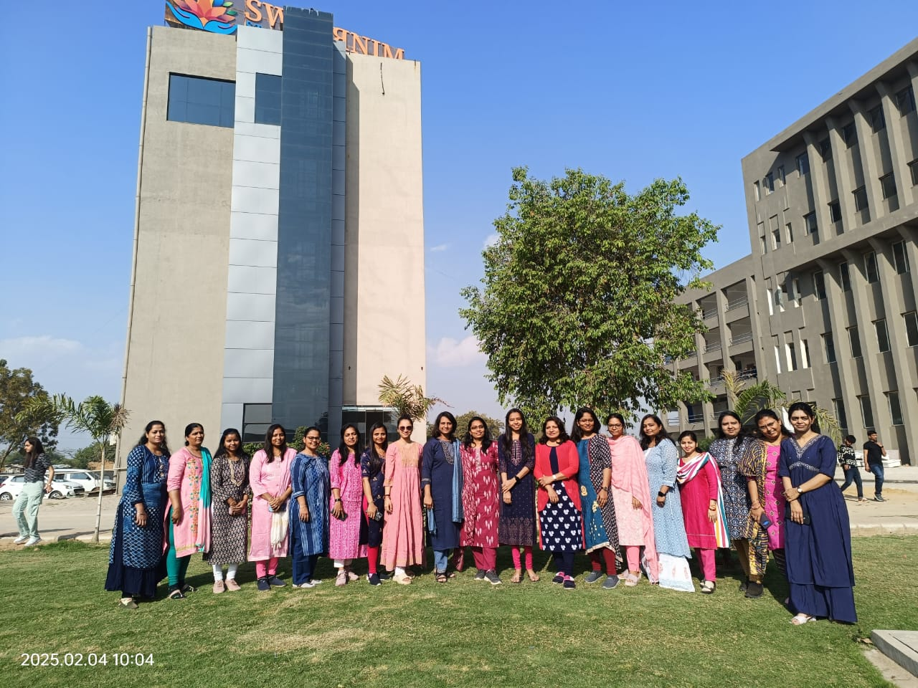
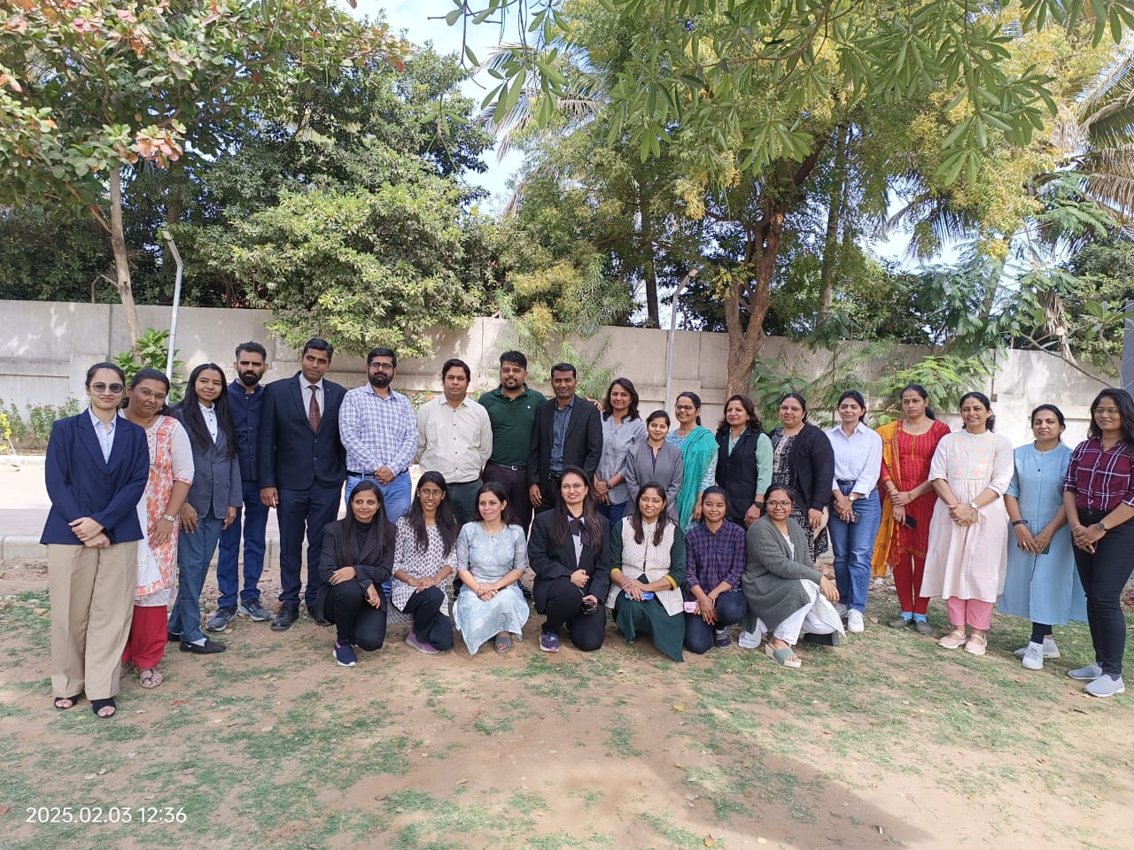
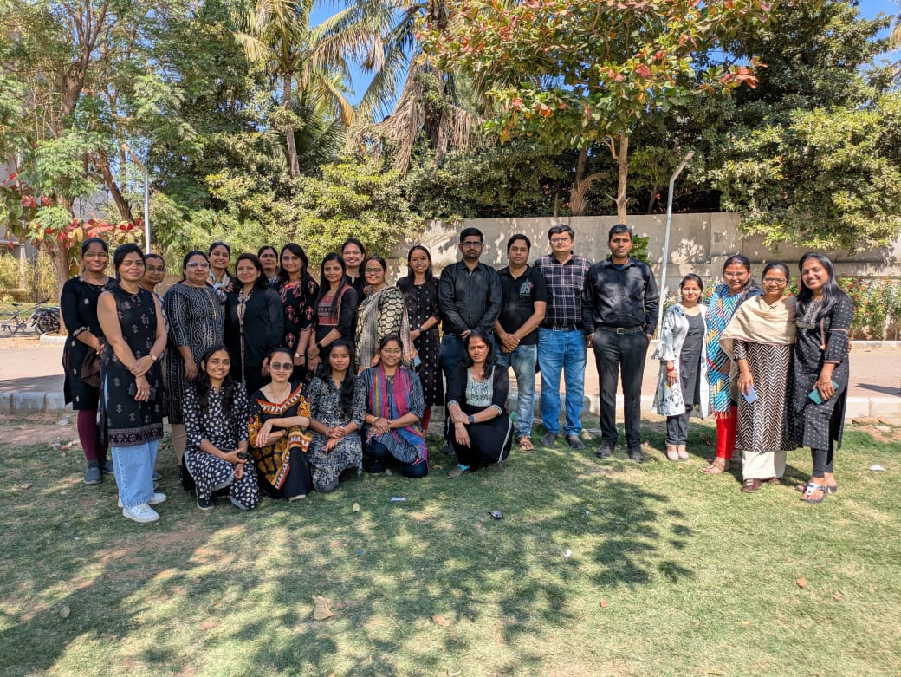

EVENT TOPIC: National Science Day

DATE: 28th Feburary 2025
TOTAL PARTICIPANTS: B.pharm and M.pharm Students

Objective of Event:
The National Science Day celebration at ASP&BRI was to inspire students to appreciate the importance of science in nation-building and to encourage innovative thinking aligned with the theme “Advancing Science and Innovation for a Viksit Bharat.” The event aimed to promote scientific curiosity, creativity, and awareness through engaging competitions and interactive sessions, motivating students to contribute meaningfully to the progress of science and society.

Outcome of Event:
The event sparked curiosity and innovation among students, enhancing their understanding of scientific concepts through engaging activities. It encouraged critical thinking and inspired them to contribute to scientific progress for a developed India.

Photographs of Event:

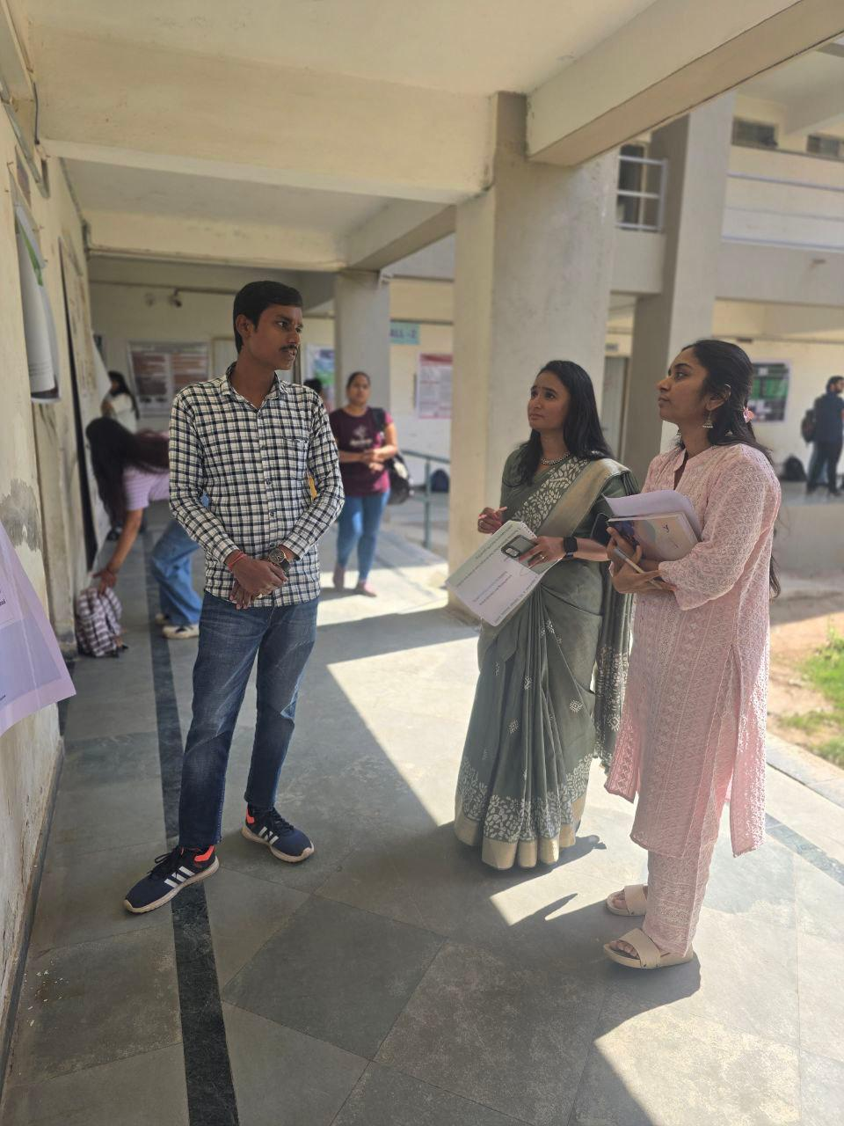

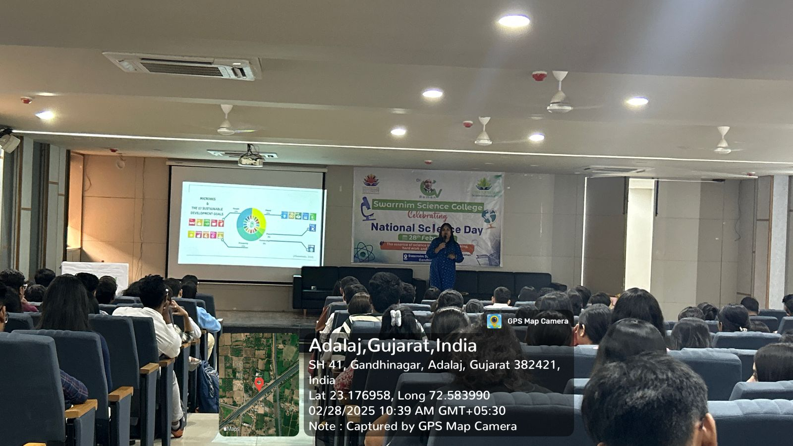

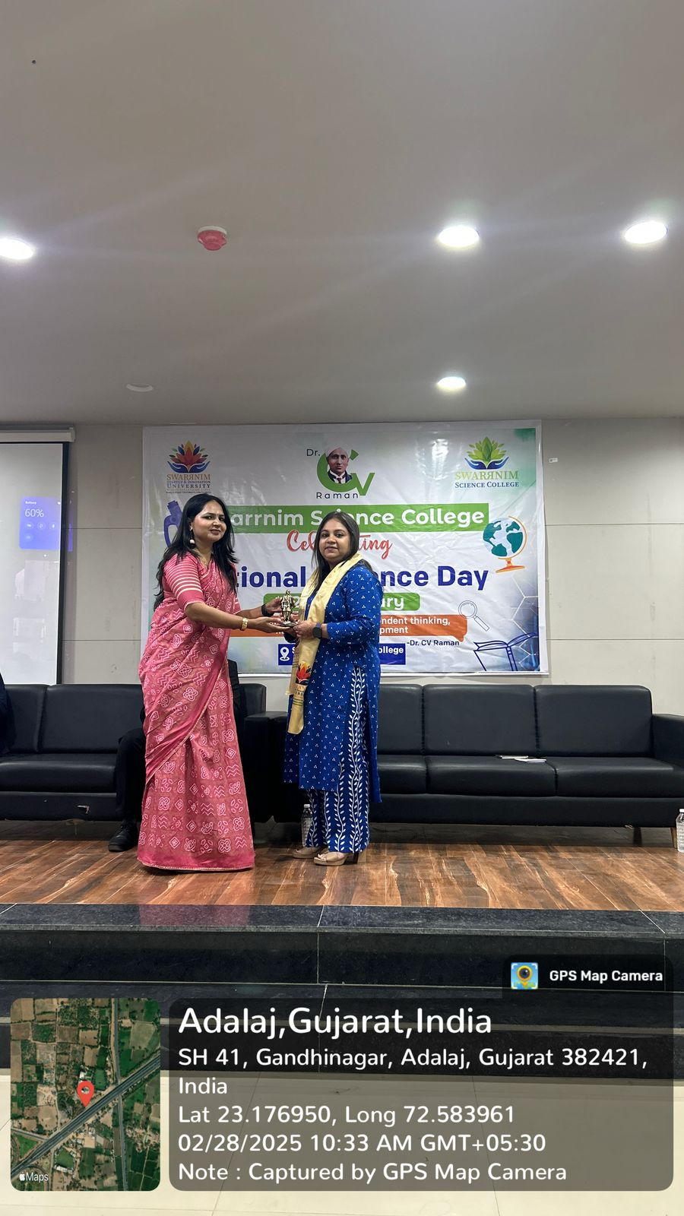
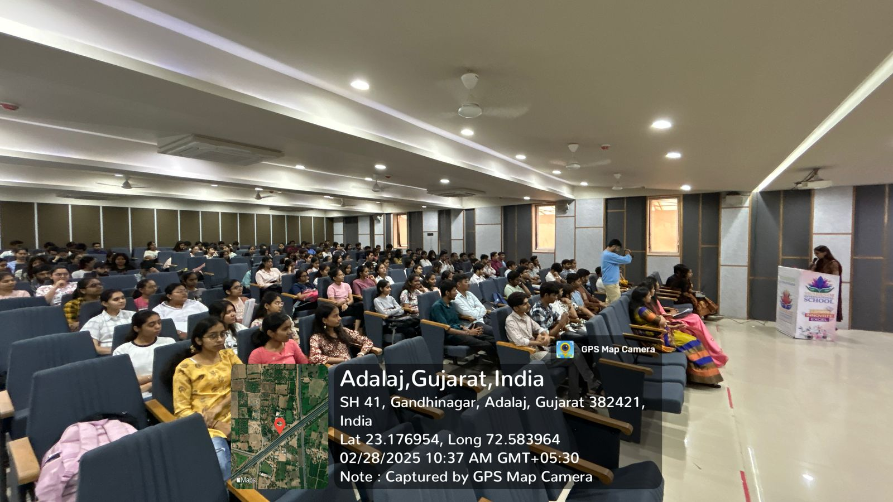

EVENT TOPIC: “Entrepre नारी 3.0 on the occasion of International Women’s Day 2025”

DATE: 4th March 2025
TOTAL PARTICIPANTS: 200 Participation from Ahmedabad and Gandhinagar.

Objective of Event: To inspire women on becoming entrepreneurs and leaders in their respective fields.
To support innovation, by providing resources and opportunities they need to thrive, startups and journey to scalable business.
Outcome of Event: The event witnessed participation from around 200 attendees, featuring 20 women-led startup exhibitions and 12 startup pitches, successfully providing a motivating platform for women entrepreneurs to showcase their potential, gain mentorship, and advance toward economic empowerment.

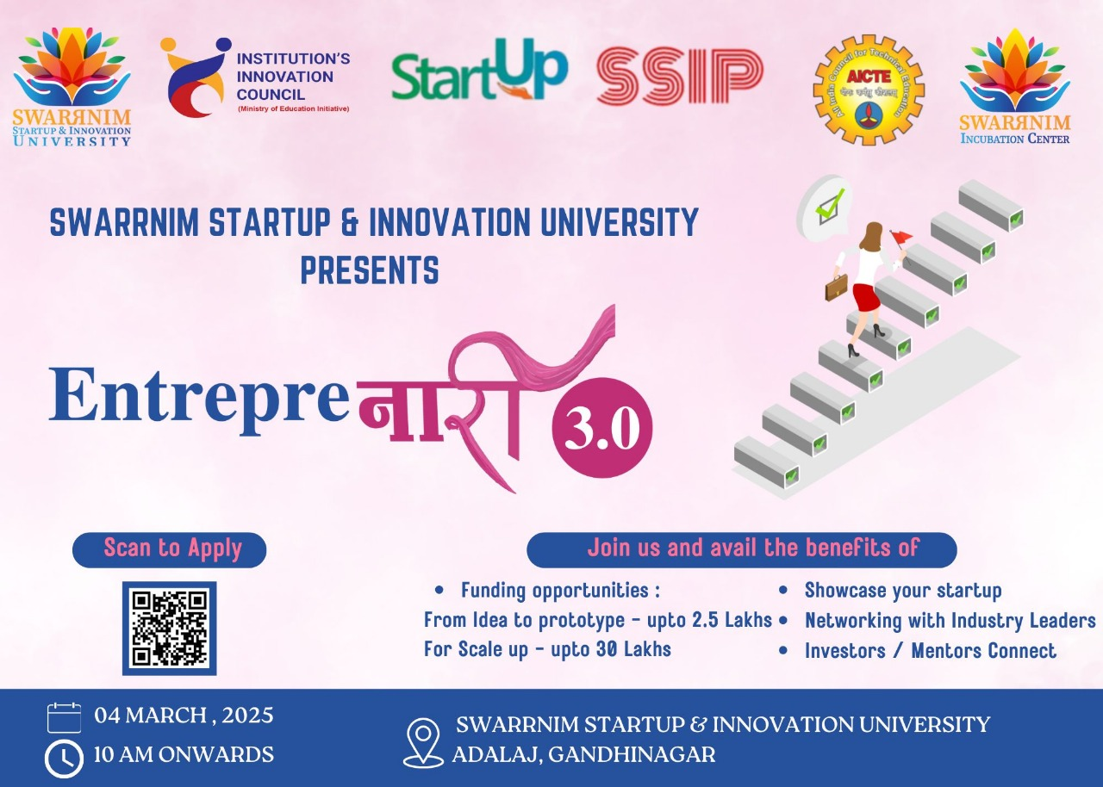

Photographs of Event:
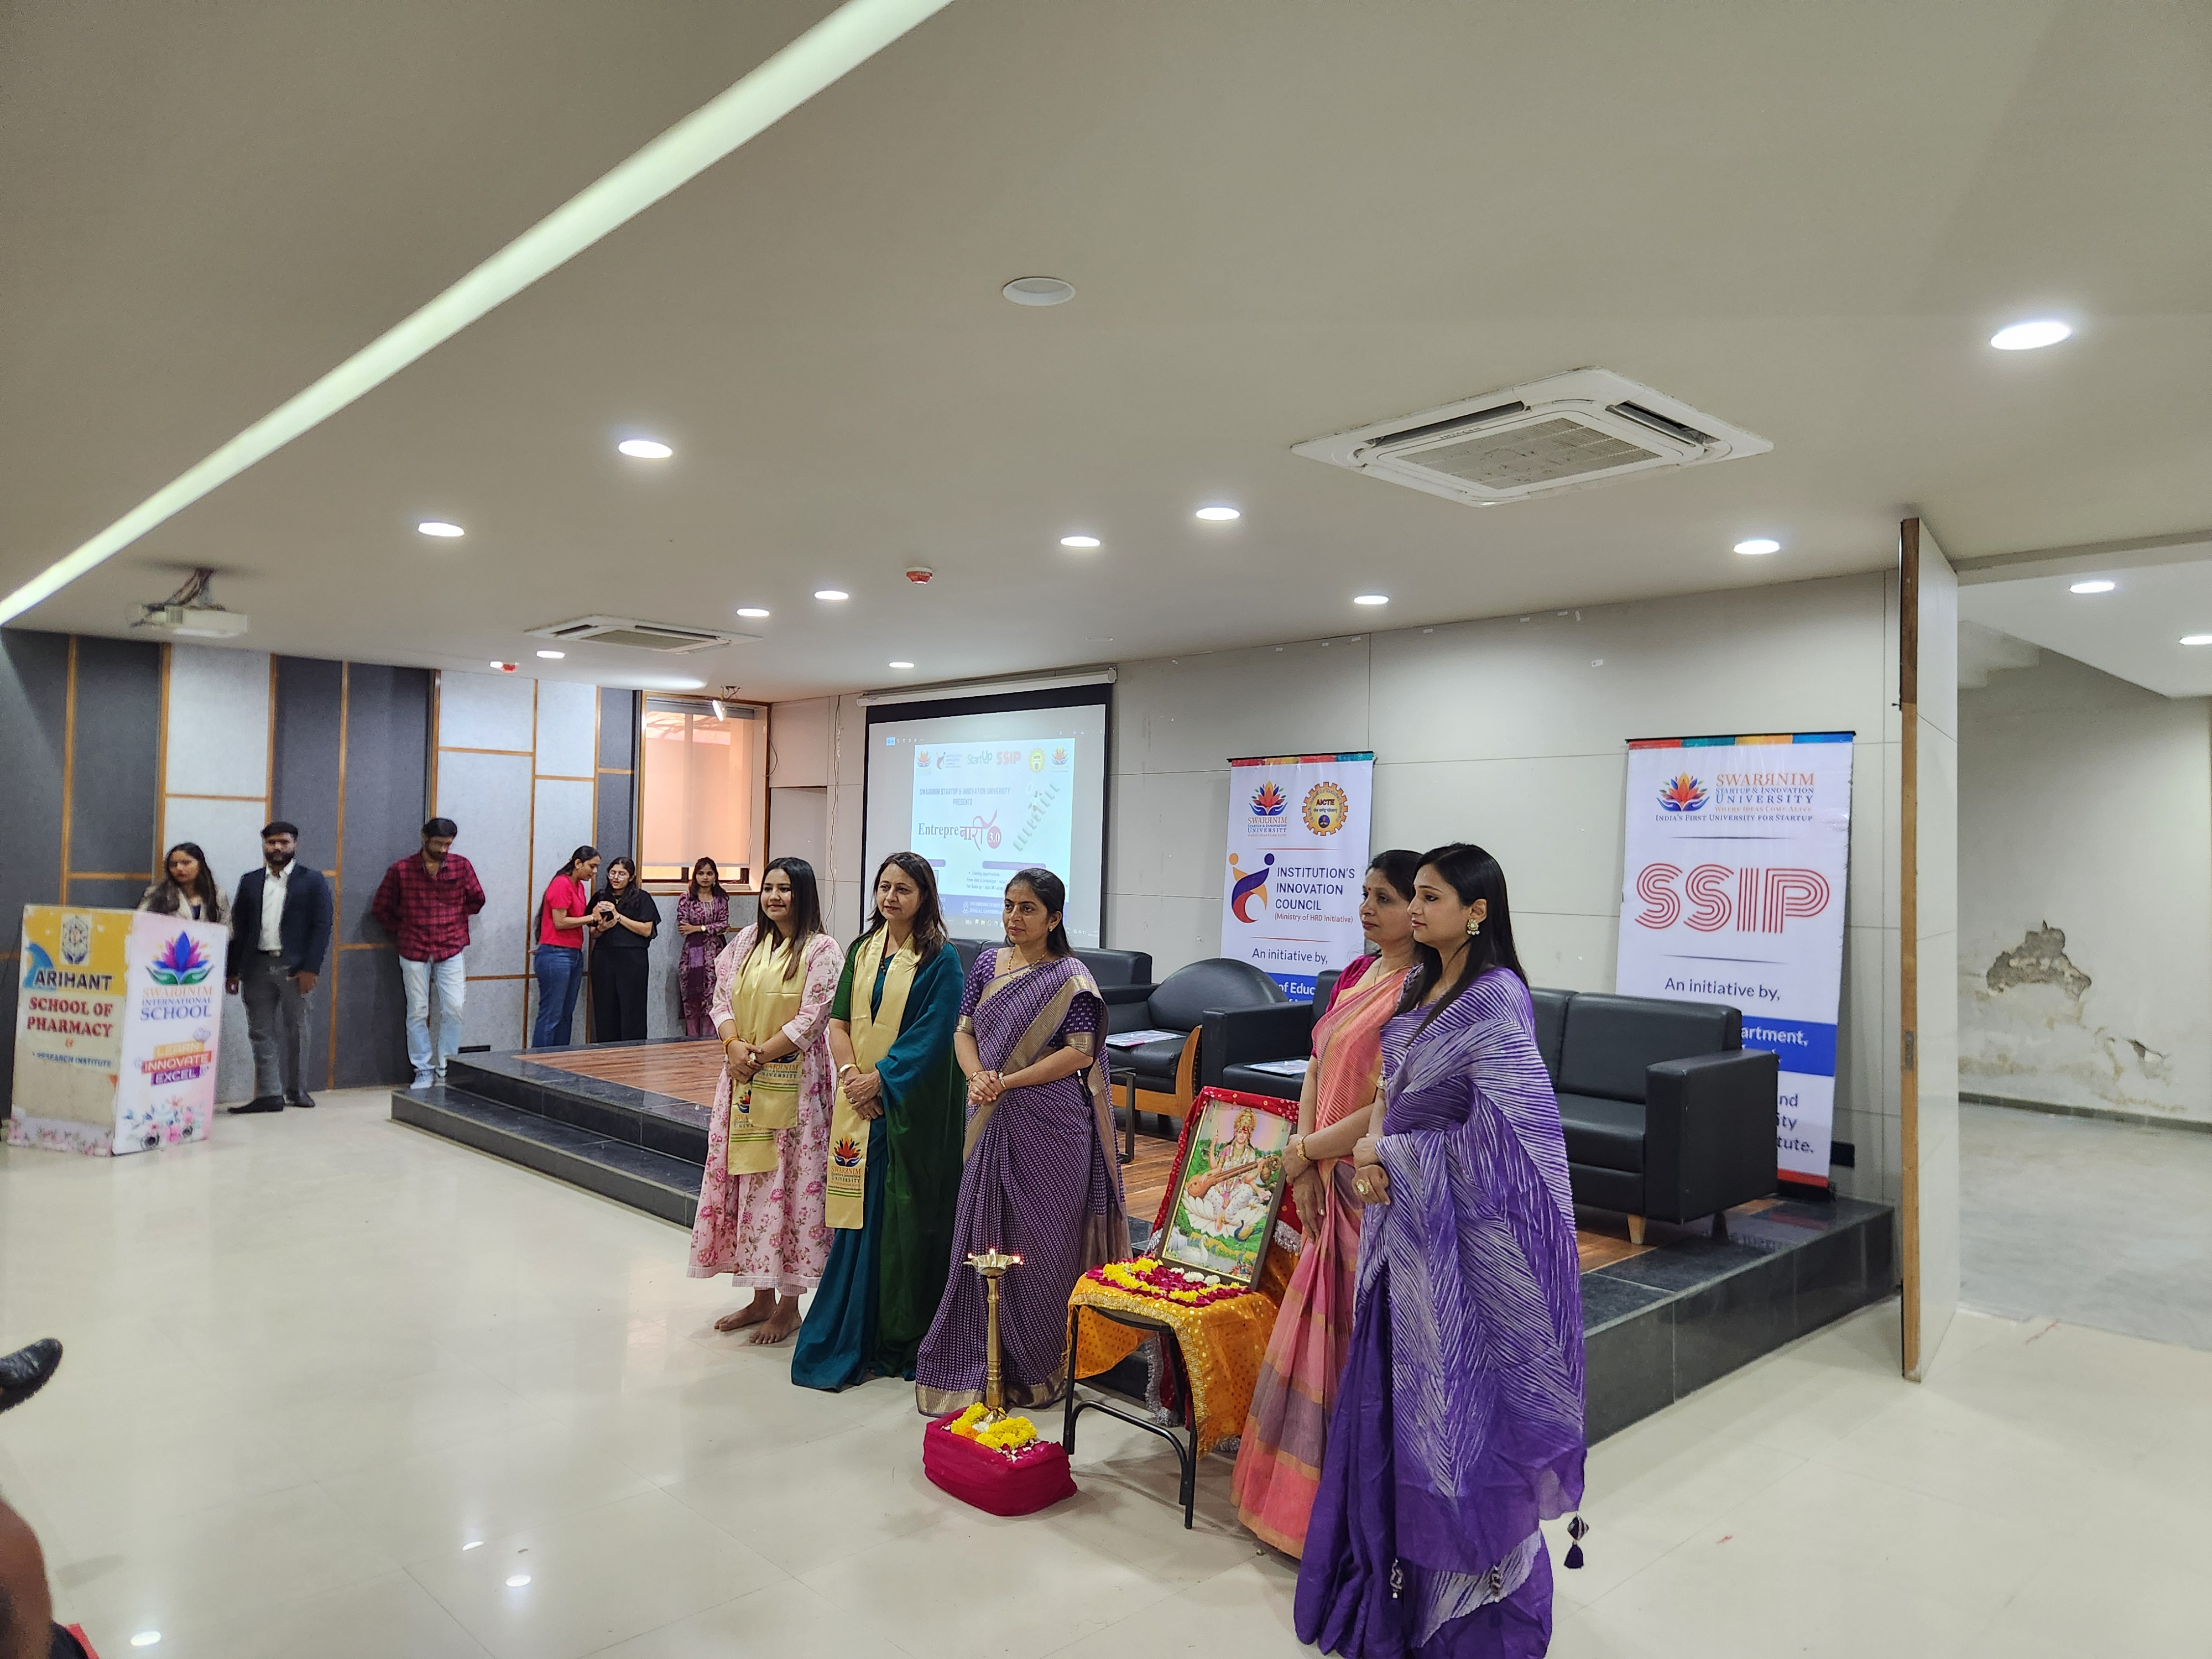
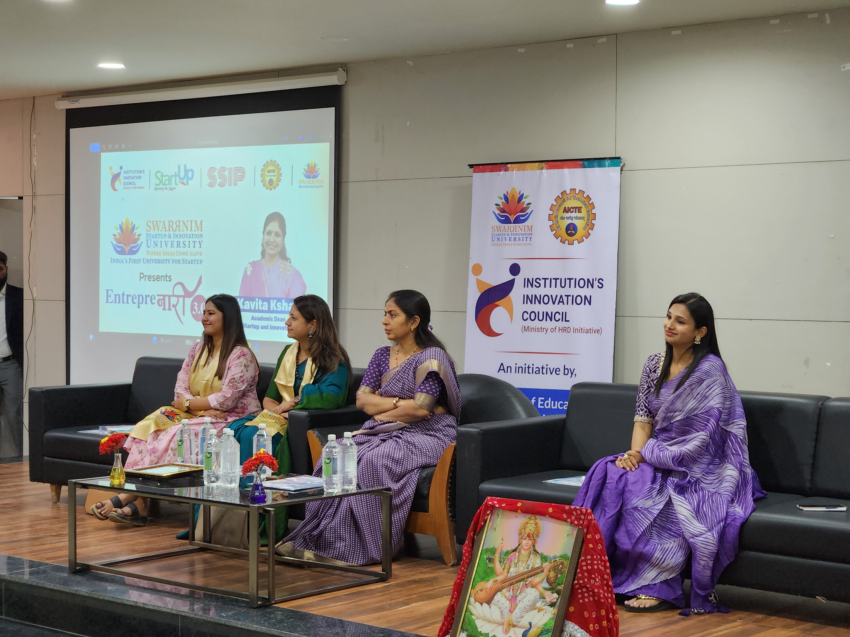

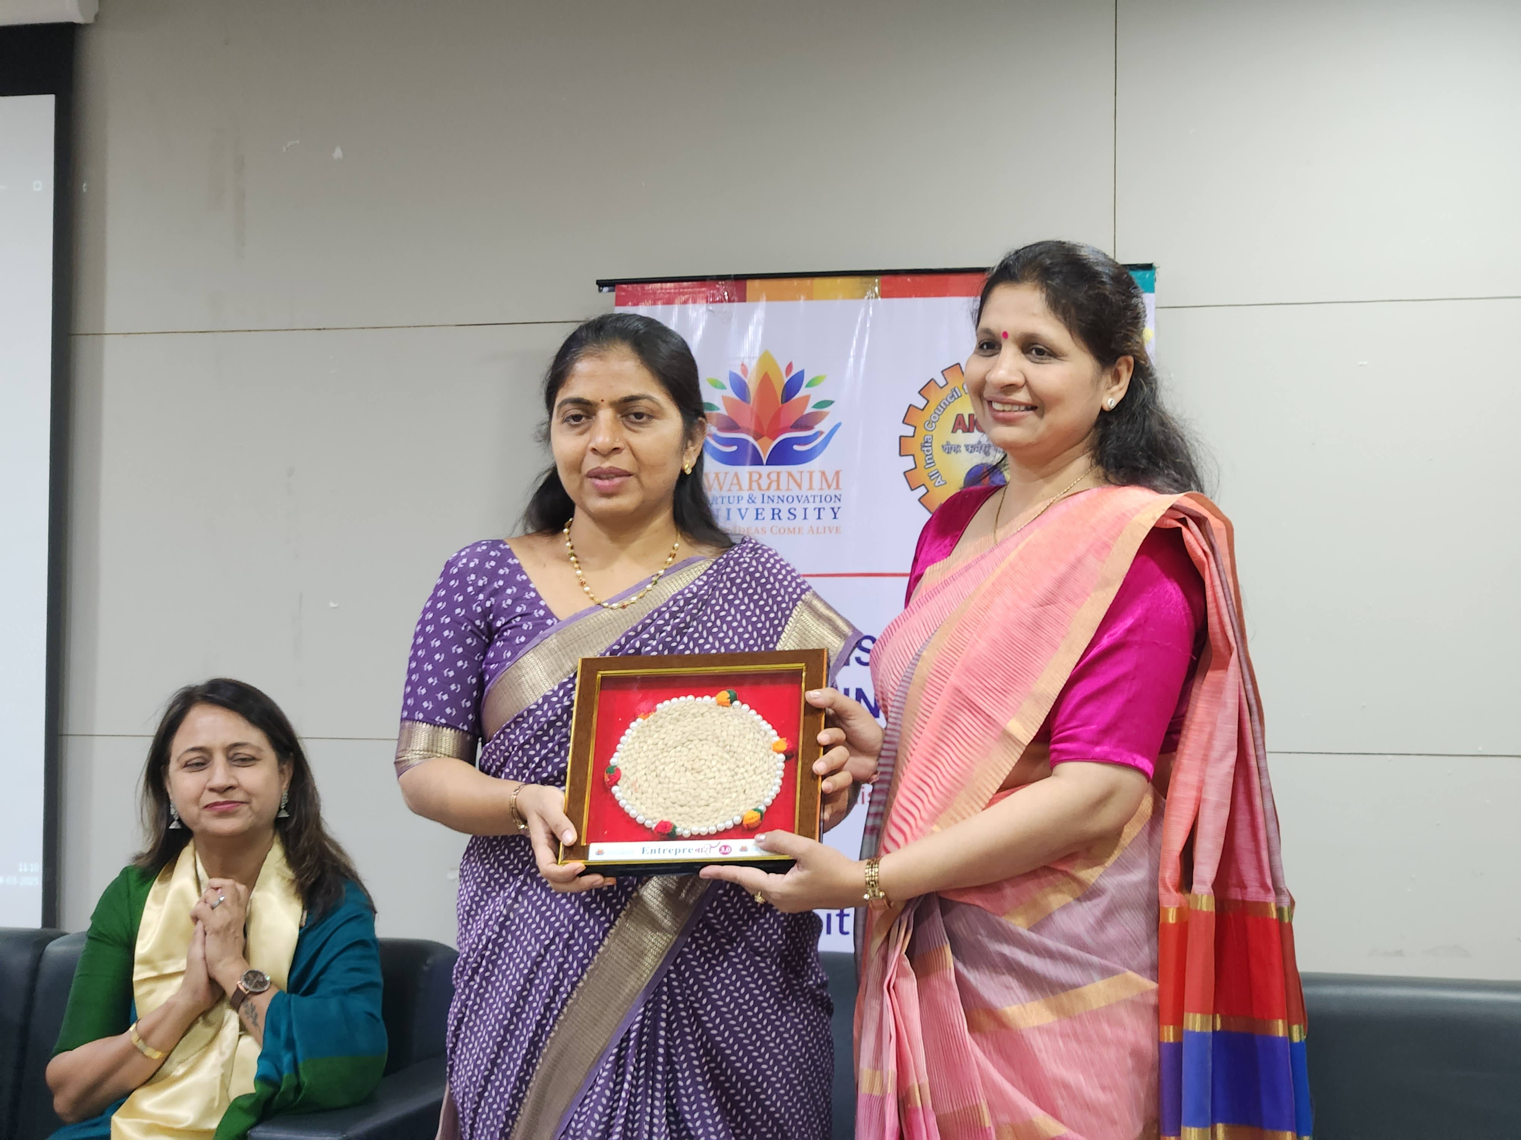
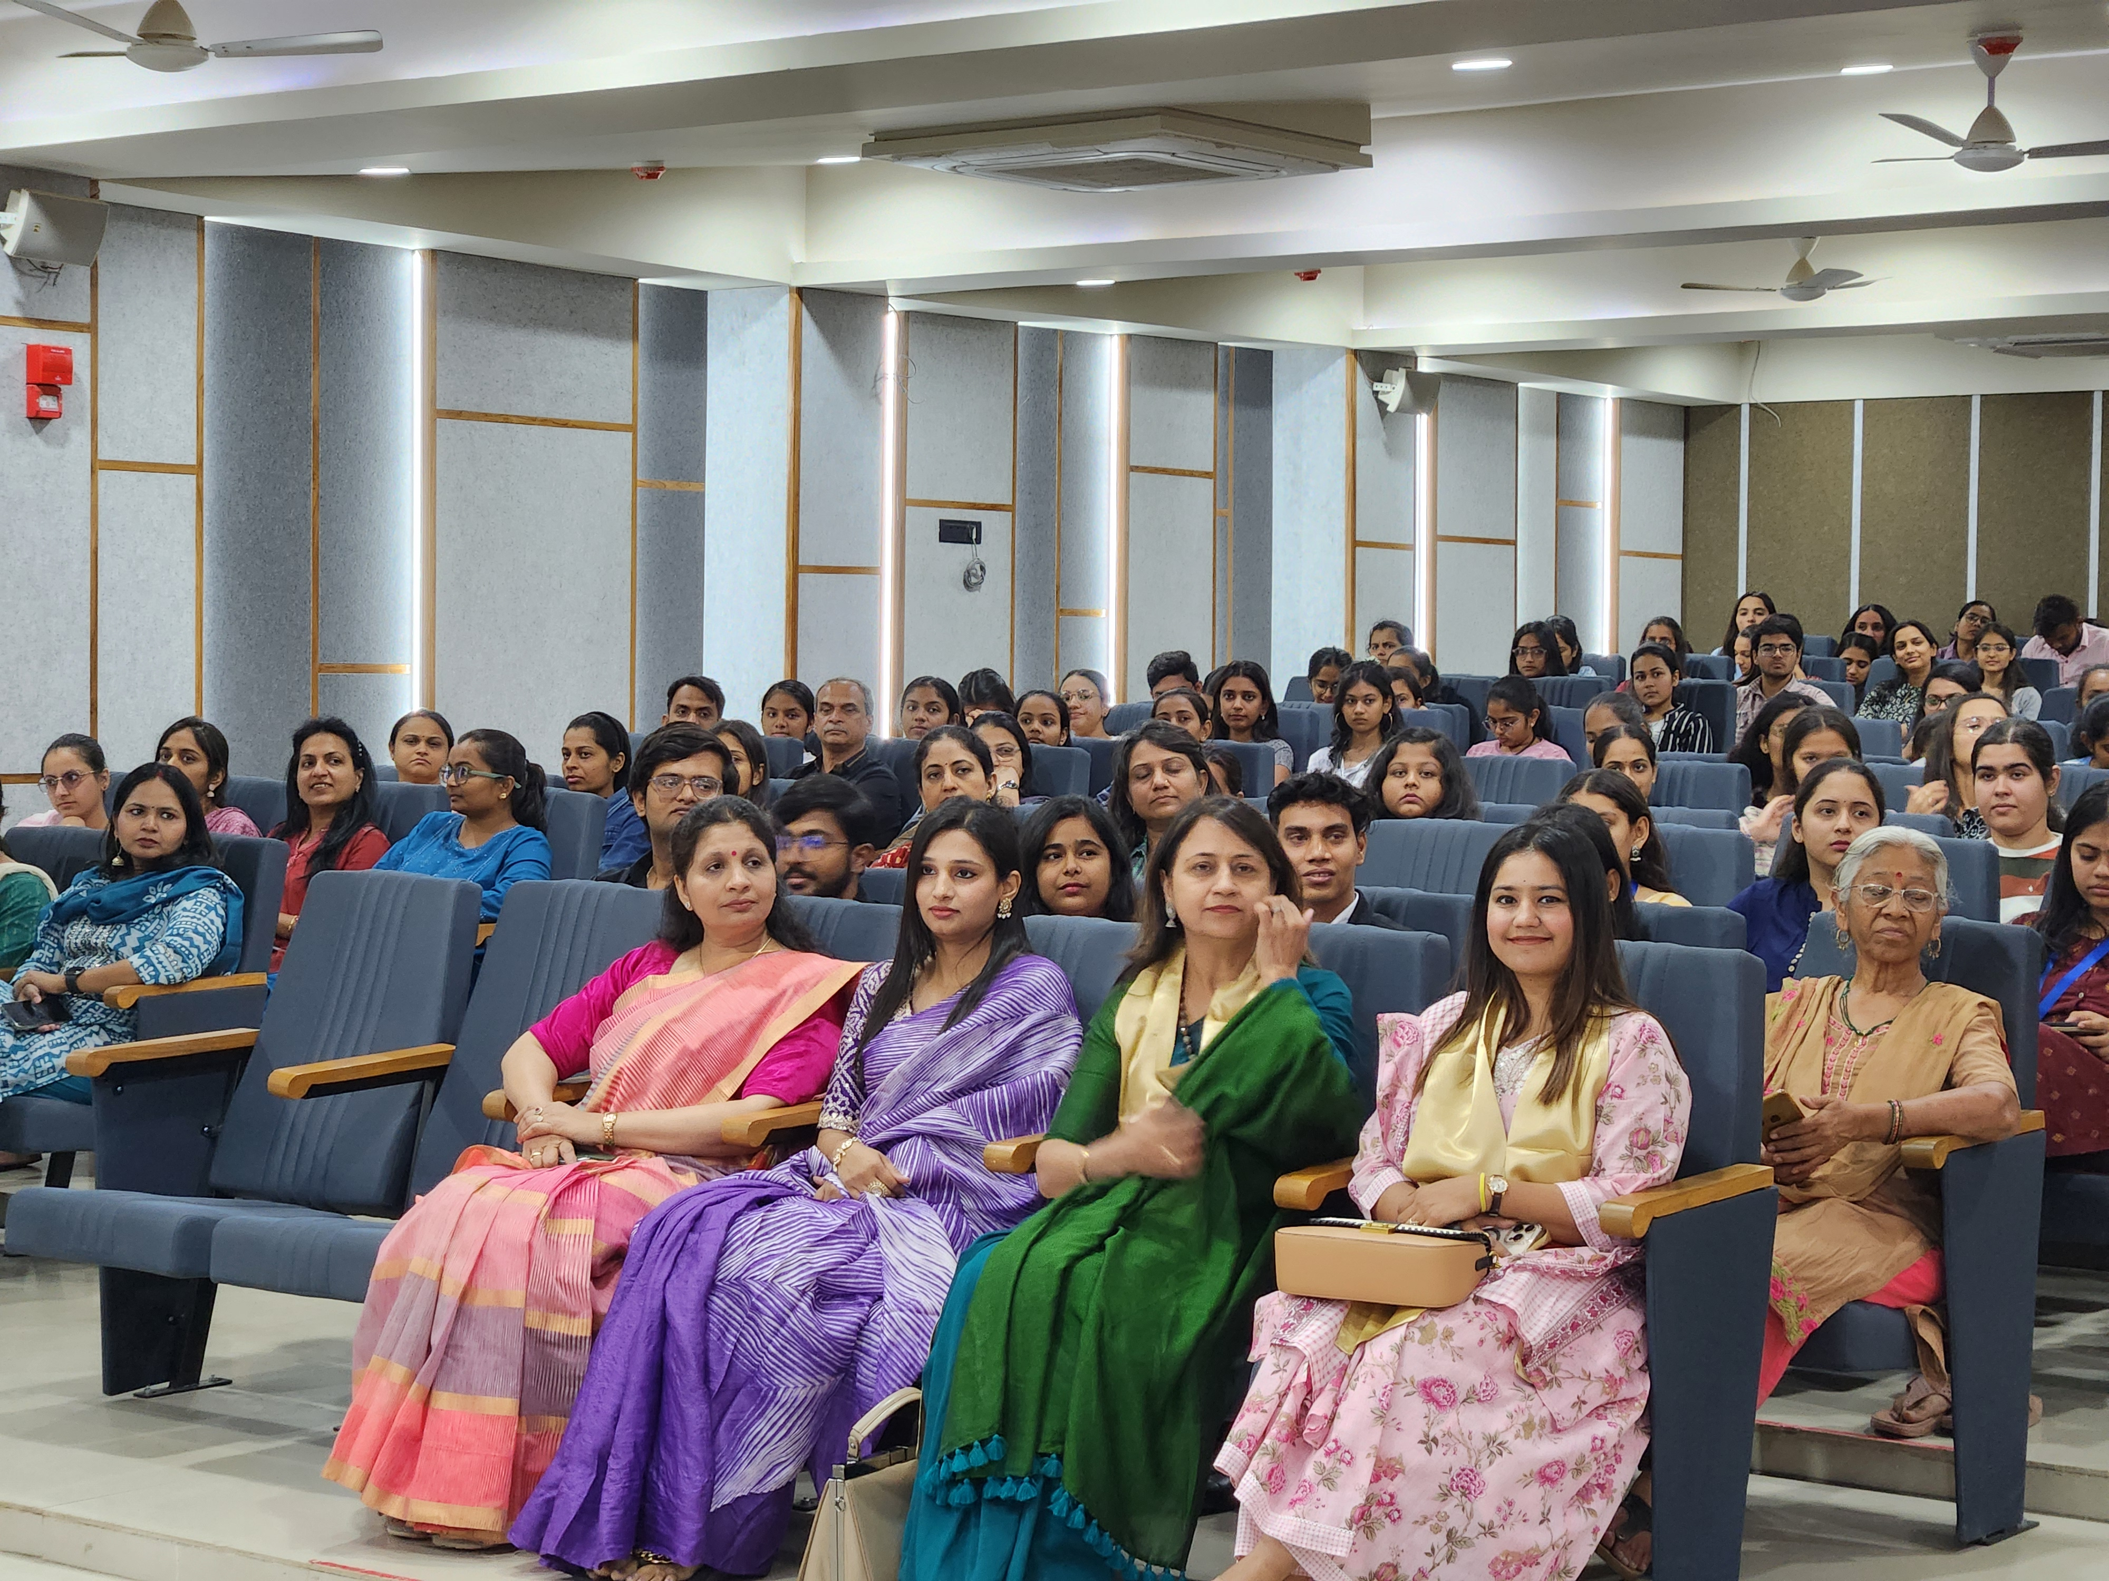

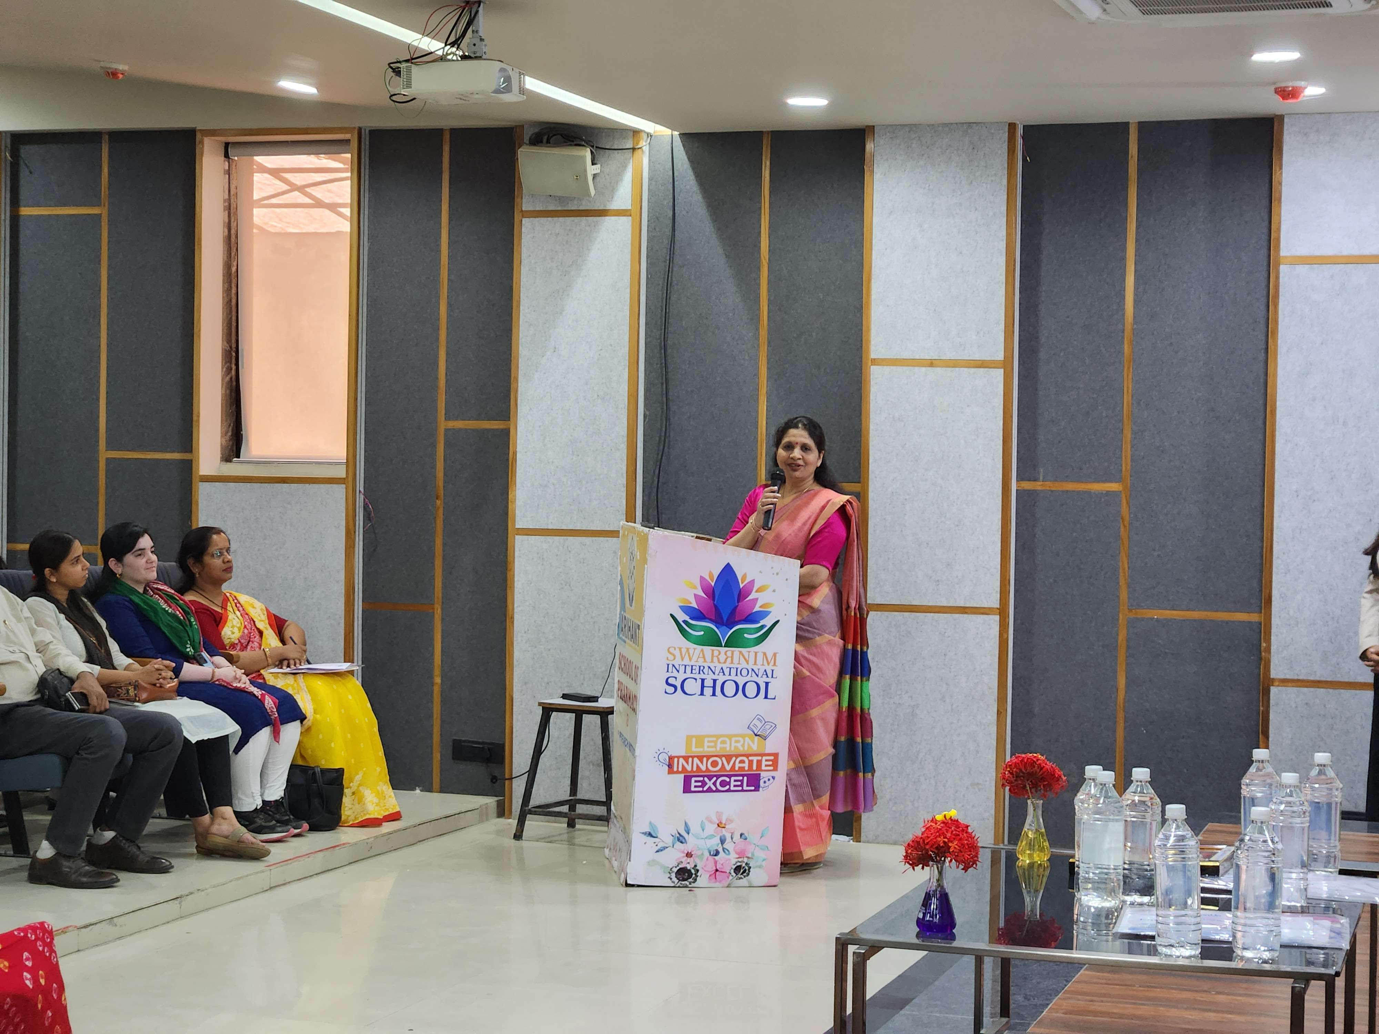
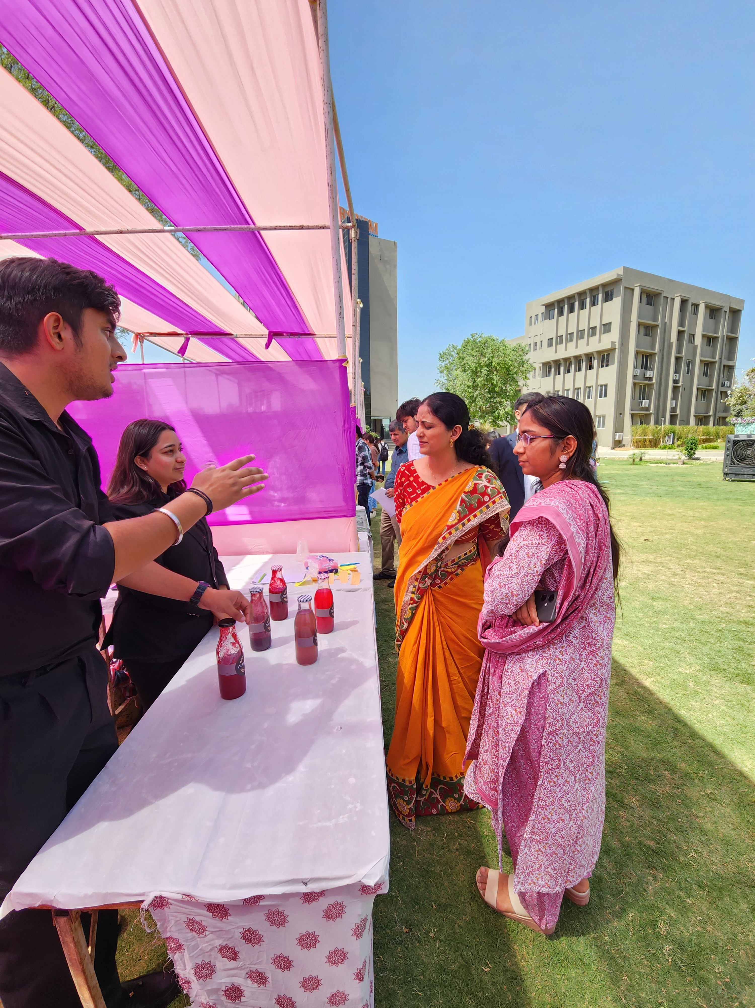

EVENT TOPIC: “Blood Donation & Thalassemia Testing Camp”
DATE: 8th April 2025
TOTAL PARTICIPANTS: 12 Blood donors & 71 Participants for Thalassemia Testing
Objective of Event: To create awareness and importance of blood donation camp & Thalassemia Testing

Description of Event:
It is said that donating one unit of blood can save the lives of three people. To create awareness and importance of blood donation & to serve the society by doing this Nobel work as well as to spread information about Thalassemia disease among students, “Blood donation camp & Thalassemia Testing camp” was very enthusiastically organized by the NSS cell of Arihant School of Pharmacy & Bio-Research Institute, Adalaj in association with Indian Red Cross Society on 08/04/2025, Tuesday between 1.00 pm to 5.00 pm. The event was organized under the coordination of Ms. Shailja Patel.

Outcome of Event: 12 blood donors donated their blood as well as 71 students who participated in the thalassemia testing in this NSS Cell of Arihant School of Pharmacy and Bioresearch Institute, Adalaj organized “Blood donation camp & Thalassemia Testing camp”

Photographs of Event:

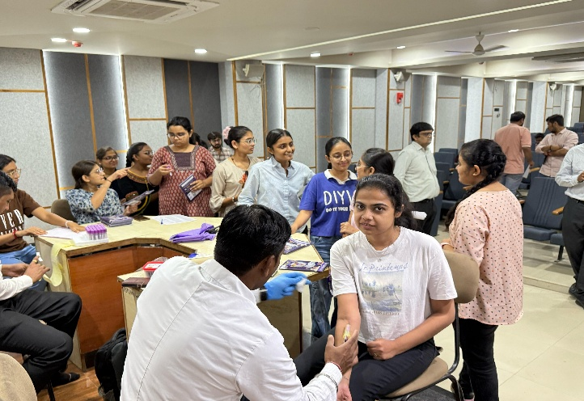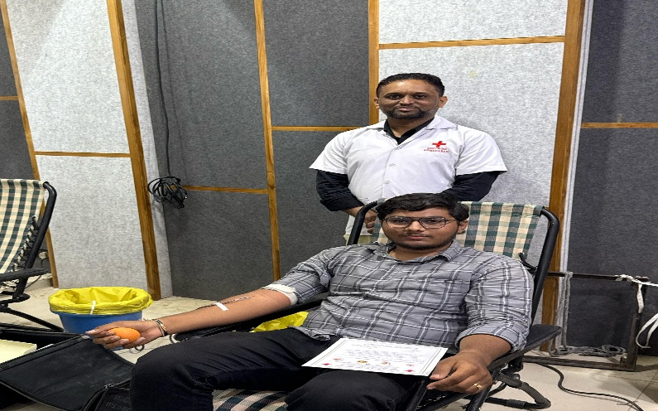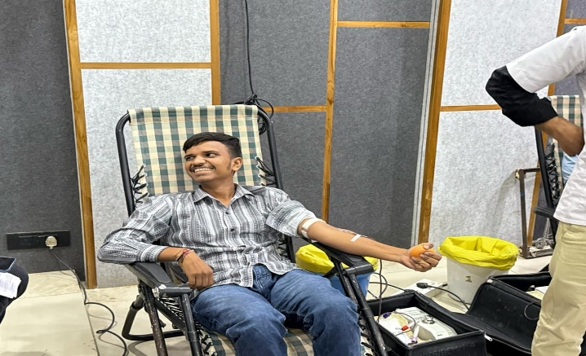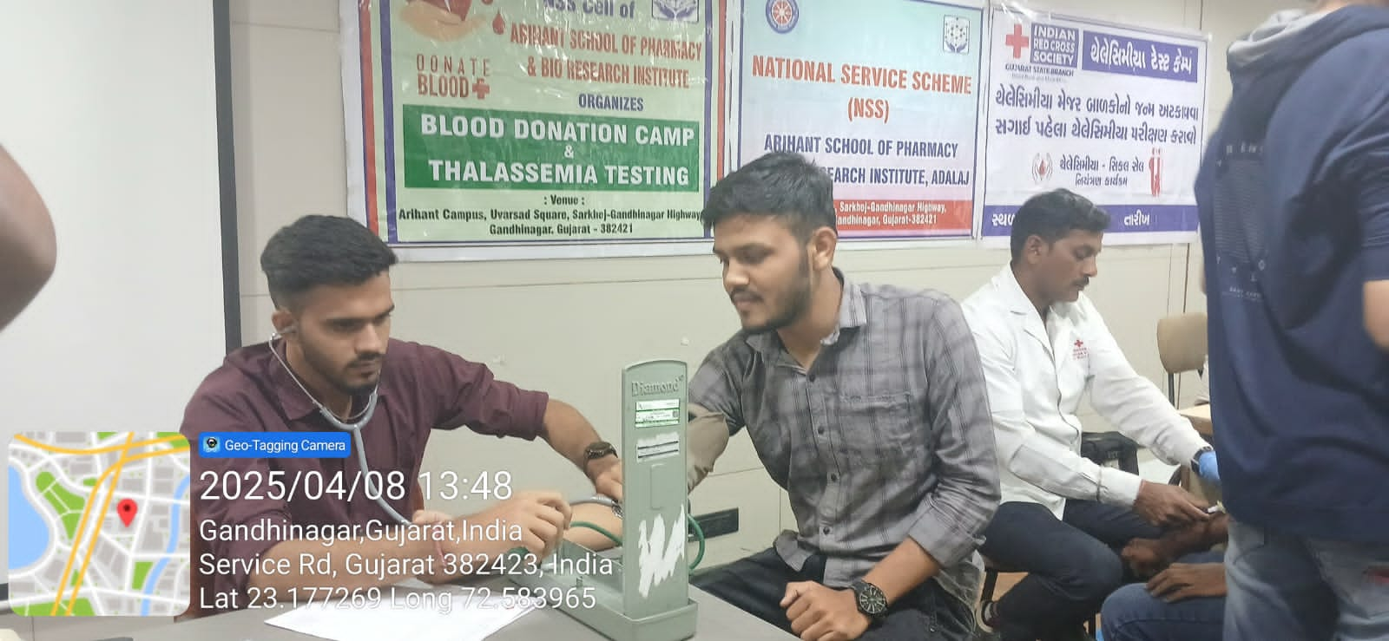

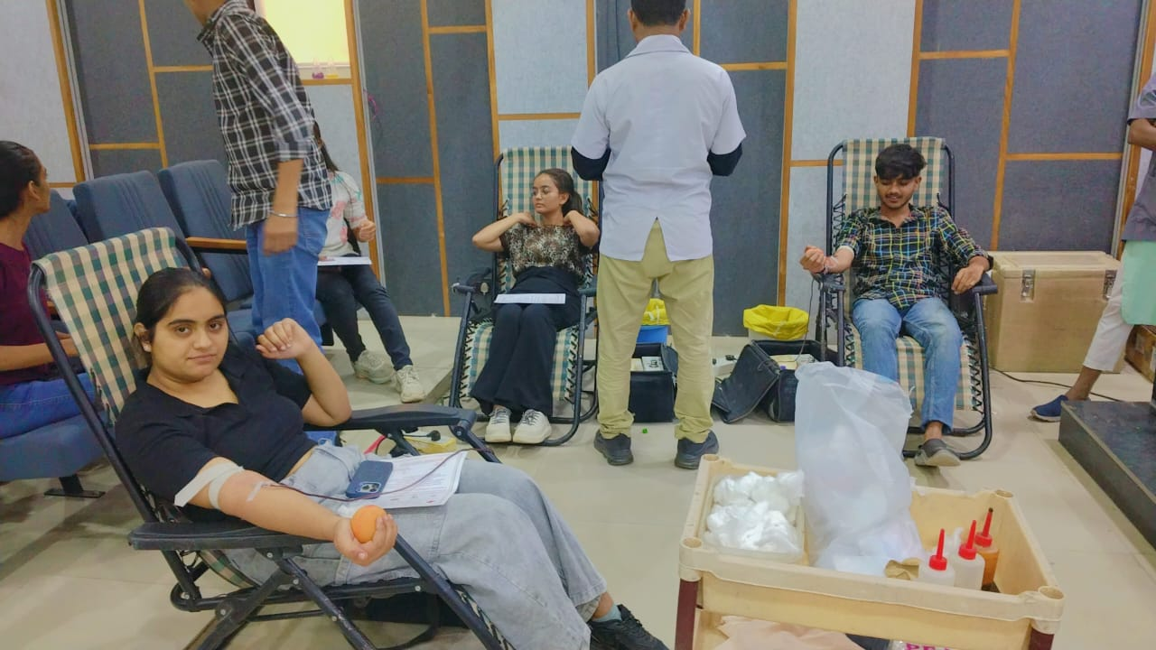

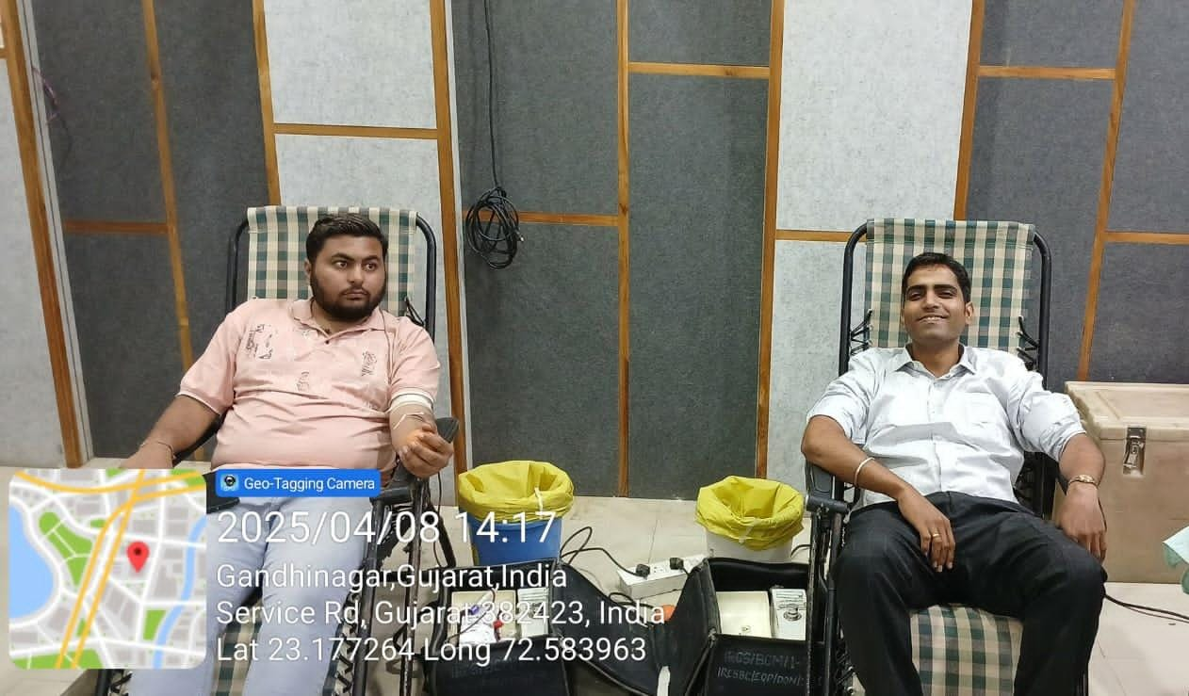

EVENT TOPIC: “International Yoga Day Celebration”
DATE: 20th June 2025
TOTAL PARTICIPANTS: 67 Participation from Arihant School of Pharmacy & BRI.

Objective of the Event: To promote yoga for better health, stress relief, and inner harmony.

Description of the Event: International Yoga Day was celebrated on 20th June 2025 at Arihant School of Pharmacy with the NSS Unit. Led by Dr. Sonali, the session included yogasanas, pranayama, Suryanamaskar, and simple exercises for relaxation. Students and faculty participated actively, highlighting yoga’s benefits for stress relief, focus, and overall wellness.

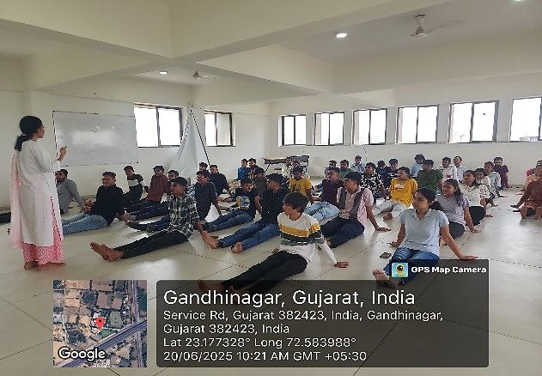
Outcome of the Event: The session boosted well-being and inspired regular yoga practice through Dr. Sonali’s guidance.

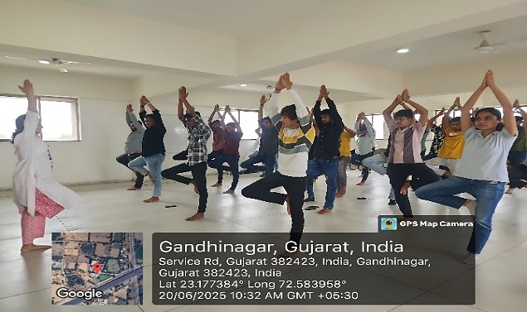
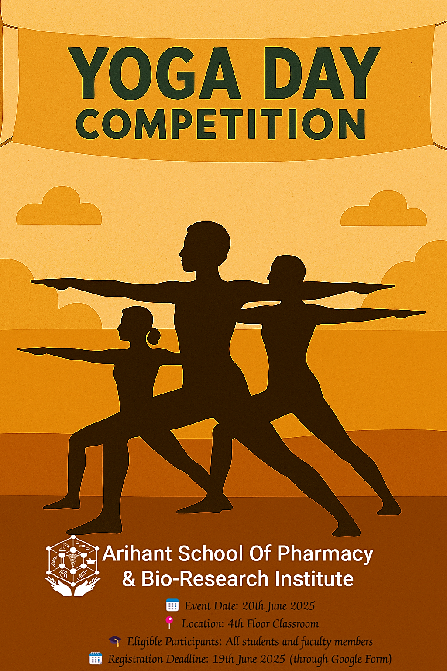
Photographs of Event:

